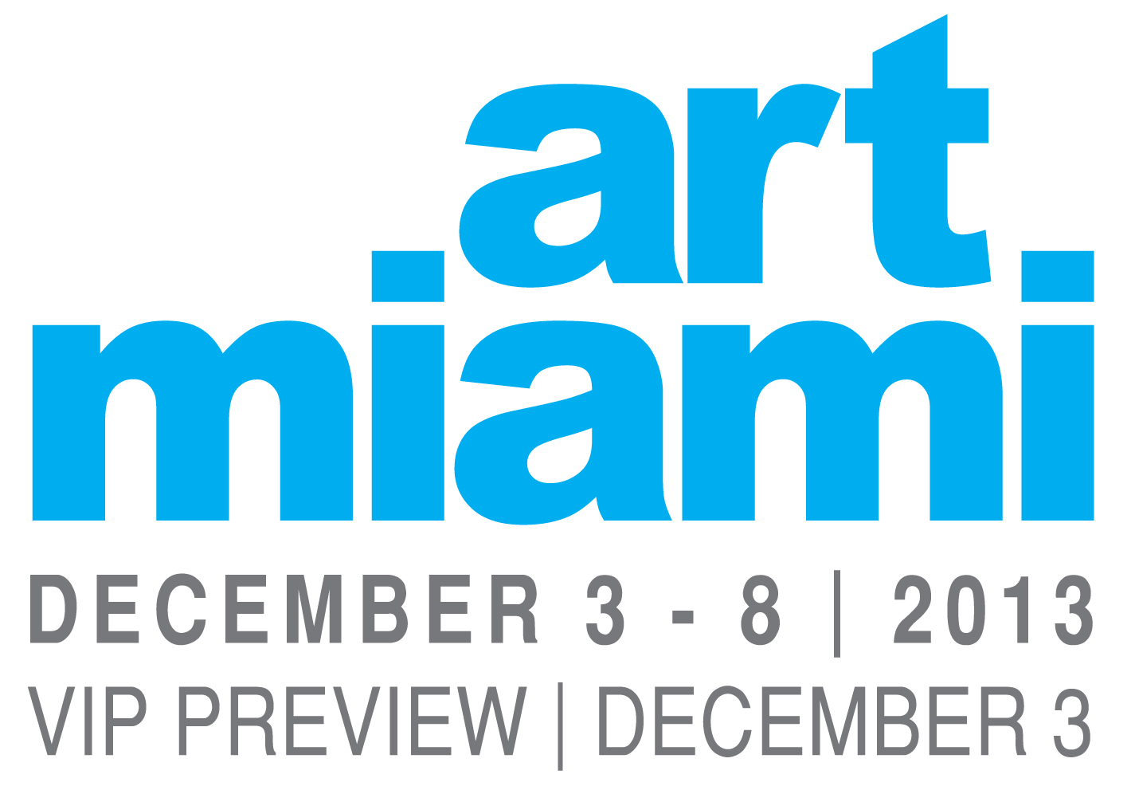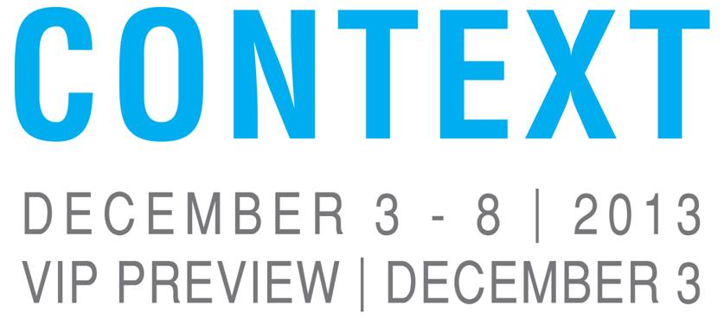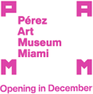
ART MIAMI ANNOUNCES PARTNERSHIP WITH PÉREZ ART MUSEUM MIAMI
Art Miami and CONTEXT Opening Night VIP Preview to Benefit PAMM Dec. 3
PAMM Art Fair Survival Party Sponsored by Art Miami and CONTEXT Nov. 16
MIAMI, Fla. (November 11, 2013) – Art Miami (www.art-miami.com) is pleased to announce its continuing partnership with the Pérez Art Museum Miami (PAMM). The museum will be the beneficiary of the Opening Night of Art Miami – Miami’s Premier International Modern and Contemporary Art Fair – and CONTEXT – Miami’s International Emerging and Cutting-Edge Art Fair.
This exclusive VIP Preview on Tuesday, Dec. 3, 2013, from 5:30 to 10 p.m. officially opens the 24th edition of the anchor art fair for the City of Miami and the second edition of its sister fair CONTEXT. The “can’t miss” reception – which has become the traditional kickoff to Miami Art Week – provides the first opportunity for international art collectors, curators and art enthusiasts to view and acquire the most important works of contemporary, modern, cutting-edge and emerging art available before the fairs open to the public the following day.
The 2012 VIP Preview, attended by 11,000 art connoisseurs, also benefited PAMM – then still known as the Miami Art Museum (MAM) – which will receive another generous donation from Art Miami LLC this year. "Art Miami has become a cornerstone of Miami Art Week and a great supporter of the museum. The opening night preview is the fair's most anticipated event, and we are very pleased to be a part of it again this year," said PAMM Director Thom Collins.
The evening also marks a very special occasion for PAMM as the museum crosses the threshold of its new 200,000-square-foot home designed by internationally acclaimed architects Herzog & de Meuron that is leading the revitalization of the downtown waterfront. “We are honored to continue our partnership with this world-class institution as it moves into its new home and ushers in a new era of our city’s development as a center for artistic scholarship and cultural innovation. We encourage our patrons to visit this architectural landmark of the future and the enlightening exhibitions inside the museum,” said Nick Korniloff, Partner and Director of Art Miami LLC.
The partnership is a natural fit for two venerable institutions that have played formative roles in the evolution of Miami’s now-booming art scene during the last three decades. Both are renowned for their dedication to illuminating the most influential international artists from the 20th and 21st centuries. Art Miami and CONTEXT feature a curated selection of exhibitors and special projects in a state-of-the-art facility with a museum-like atmosphere spanning 250,000 square feet of indoor and outdoor exhibition space.
"I have been attending Art Miami for many years and have found phenomenal works of art there that I have purchased both for my personal collection as well as my buildings," said Jorge Pérez, Chairman and CEO of the Related Group of Florida and namesake benefactor of PAMM. “Having a fair based in and developed out of Miami that we can call our own during this international week of art is very important for our city and the development of Miami's art community. We're excited to have Art Miami's continued support of the Museum.”
World-renowned for its refined ambience, consummate quality and accessible diversity, Art Miami now encompasses all levels of the international modern and contemporary art market: from the masterpieces and blue-chip works at Art Miami to the cutting-edge gems by exceptional rising and mid-career talents at CONTEXT. The 125 exhibitors at Art Miami together with 69 at CONTEXT form a cosmopolitan art community in the Wynwood Arts District with galleries hailing from more than 50 cities in 22 countries in the Americas, Europe and Asia. The 2012 debut of this winning combination broke Art Miami’s attendance records with more than 60,000 visitors and generated sales of more than $50 million.
“The level of participating galleries only continues to improve each and every year. This is a great night – and we don’t miss it,” said Dennis Scholl, who represents The Knight Foundation on PAMM’s board of trustees and co-founded the museum’s Collectors Council with wife Debra Scholl. “We really appreciate Art Miami and CONTEXT making the gesture to continue to support the local arts community with the VIP Preview benefitting the Pérez Art Museum Miami.”
Art Miami and CONTEXT are also proud to continue as sponsors of the PAMM Contemporaries Art Fair Survival Party, an important fundraiser for the museum’s support group for young professionals that starts the countdown to Art Week on Saturday, Nov. 16 from 7 to 10 p.m. at the Dolce Italian rooftop lounge in the Gale South Beach hotel. The members-only party is the highlight of the PAMM Contemporaries’ social calendar, where members get ready for Miami Art Week and receive their Survival Kits including event invitations and VIP passes to the Art Miami, CONTEXT and Aqua Art Miami.
All Art Miami and CONTEXT VIP cardholders are invited to PAMM’s Big Jam on Dec. 5 from 7 to 11 p.m., featuring a one-night-only performance and installation designed specifically for the new building and its landscaped surroundings by the multimedia collaborative LOS JAICHACKERS. Art Miami VIP cardholders will also enjoy free admission during regular museum hours throughout the Fair.
FAIR INFORMATION info@art-miami.com or +1.305.515.8573
LOCATION
The Art Miami + CONTEXT Art Miami Pavilions
Midtown Miami | Wynwood Arts District
3101 NE 1st Avenue Miami, FL 33137
VIP PREVIEW - Tuesday, December 3 | 5:30 pm - 10 pm
Access for Art Miami + CONTEXT VIP Cardholders & Press
Benefitting the Pérez Art Museum Miami
GENERAL ADMISSION
Wednesday, December 4 11 am – 7 pm
Thursday, December 5 11 am – 7 pm
Friday, December 6 11 am – 8 pm
Saturday, December 7 11 am – 7 pm
Sunday, December 8 11 am - 6 pm

ACCOMMODATIONS
Art Miami and PAMM are pleased to partner with the JW Marriott Marquis Miami and
Hotel Beaux Arts Miami as the Official Hotels of the 2013 Fairs
Contact: Magda Stark
E: magdas@universal-travel.com
T: (248) 635-8282
International: (954) 761-1500 x 256
Toll Free USA: (800) 735-0401 x 256
MEDIA CONTACTS
VIP Relations, Marketing, Sponsors + Partners
Pamela Cohen
E: Perminak@comcast.net
T: (561) 745-5690
Press Relations
DKC Public Relations Margery Gordon
E: artmiami@dkcnews.com Communications Manager
Miami: Victoria Martinez Hart Art Miami LLC
T: (786) 470-3774 E: mgordon@art-miami.com
New York: Diana Kashan T: (305) 868-5681
T: (212) 981-5161 C: (305) 989-0027

ABOUT ART MIAMI LLC
Art Miami LLC is a partnership consisting of art and media industry veterans Nick Korniloff, Mike Tansey and Brian Tyler. The company annually presents a trio of fairs during Art Week: the 24-year-old flagship Art Miami – Miami's Premier International Contemporary and Modern Art Fair; CONTEXT – Miami’s International Emerging and Cutting-Edge Art Fair, launched in 2012; and the recently acquired Aqua Art Miami – among the top fairs for emerging art since 2005. The Art Miami family also encompasses three international fairs of contemporary and modern art at other times of each year: Art Wynwood, over Presidents Day weekend in February, with an additional focus on the growing street art movement; the prestigious Art Southampton in July at the height of the cultural season in this legendary New York retreat for artists and collectors; and the innovative Art Silicon Valley/Art San Francisco that debuts in October 2014.
ABOUT ART MIAMI
Miami's Premier International Contemporary and Modern Art Fair, Art Miami is world-renowned for its outstanding quality, extraordinary variety and stylish gallery-like decor. Miami’s longest-running contemporary art fair will celebrate its 24th edition December 3-8, 2013, presenting 125 of the most prominent galleries from more than 50 cities in 17 countries, as well as enlightening curated exhibitions and special events. The anchor art fair for the City of Miami will once again be held in an elegant 125,000-square-foot pavilion in Miami’s burgeoning Wynwood Arts District. www.art-miami.com
ABOUT CONTEXT
CONTEXT is the sister fair to Art Miami that focuses on international cutting-edge and emerging art. Its second edition December 3-8, 2013, features a select group of 69 trendsetting galleries who represent exceptional emerging and mid-career artists, in addition to solo artist projects, multimedia experiences and educational symposia. CONTEXT’s state-of-the-art 45,000-square-foot pavilion is connected to Art Miami by a courtyard that encompasses curated outdoor installations and video viewing booths, a lounge and a café. www.contextartmiami.com
ABOUT PÉREZ ART MUSEUM MIAMI (PAMM)
Pérez Art Museum Miami (PAMM) advances public knowledge and appreciation of art, architecture and design with a permanent collection and traveling exhibitions that reflect the diverse community of its pivotal geographic location at the crossroads of the Americas. This 29-year-old institution, formerly known as Miami Art Museum (MAM), is moving into a new building in Downtown Miami’s Museum Park designed by world-renowned architects Herzog & de Meuron and slated to open December 4, 2013. The facility is a state-of-the-art model for sustainable museum design and progressive programming, encompassing 200,000 square feet of indoor and outdoor space with sprawling galleries, shaded verandas, a waterfront restaurant and bar, a museum shop, and an education center with a library, media lab and classrooms.

